# Cooking with CQL Qs&As with Classifications for the RC – SESSION 27

**7/26/2018 - Cooking with CQL: or How to Incorporate CQL into HQMF for eCQMs Qs&As**

[**Measure Representation**](https://ecqi.healthit.gov/cql/CQ-Qs%26As#MeasureRepresentation)

**Q. In the ED encounter observation expression, can the union be used with both option 1 (use of an Encounter code to model observation) and option 2 (use of an Encounter facility location to model observation)?**

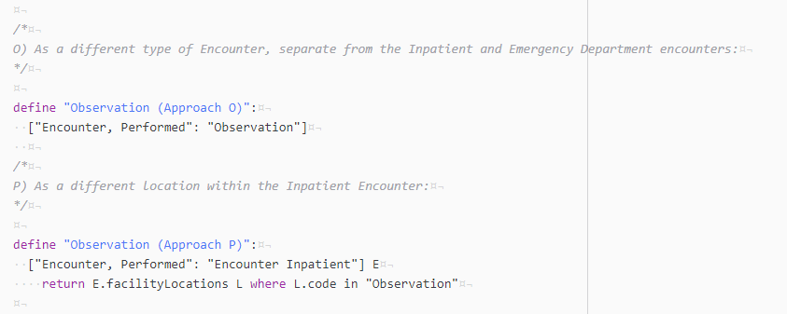

**A.** The “union” in this question is referring to the common use of unions to bring together encounters from different value sets in to a single expression for consideration. With option 1, because the observation status is determined by looking at a facility code, the encounter codes are still used in the way that they are now (i.e. to represent the type of encounter: inpatient, outpatient, etc.). With option 2, however, “Observation” is represented as another type of encounter, so you wouldn’t be able to distinguish other types of encounters within Observation.

**Q. Does the logic shown cover a scenario where the patient goes from outpatient status directly to inpatient?**

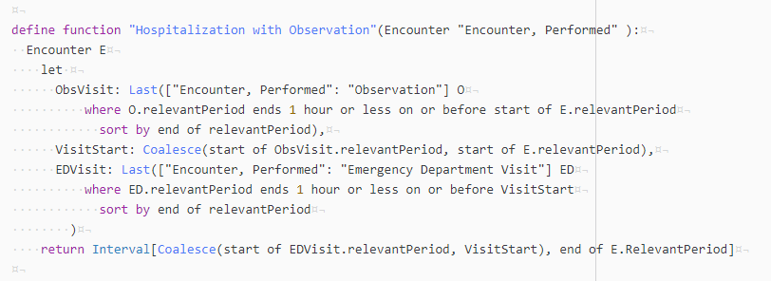

**A.** Yes, because there would be no observation or ED visit. The outpatient visit can be compared to the start of the encounter’s relevant period.

**Q. Can the ‘define function’ pattern be used to customize measures where an outpatient visit is not to be considered as an episode of care?**

**A.** Yes, in that case, you would use the Hospitalization with Observation function rather than the Hospitalization with Outpatient function. In addition, measures that did not consider observation status to be part of the episode of care would continue to use the current Hospitalization function.